**Linux for DevOps**

**What is Linux?**

**Linux is an open-source operating system. This means anyone can use it for free, see its code, and even change it if needed. It was created by Linus Torvalds in 1991 and is based on an older system called Unix.**

There are many versions of Linux, called distributions, some popular ones are:

**Ubuntu: Easy to use, great for beginners.**

**Fedora: Latest features and updates.**

**Debian: Stable and reliable for servers.**

**CentOS: Good for businesses and web servers.**

**Kali Linux: Used for cybersecurity and hacking.**

**Arch Linux: Made for advanced users who like customization.**

**How Linux Works (Simple Architecture) :**

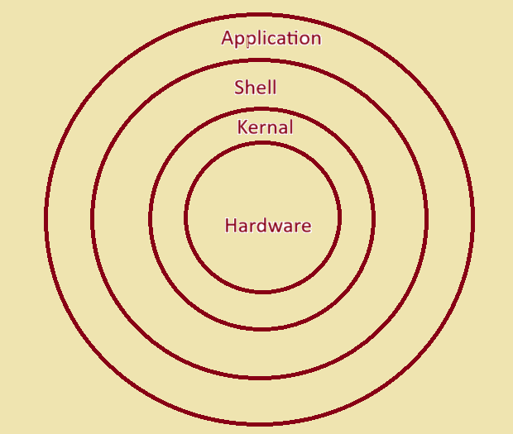Linux is made of three main parts:

1. Applications: These are the programs you use, like web browsers (Firefox), text editors (Vim), or office tools (LibreOffice).

2. Shell: This is a program that lets you talk to the linux system using commands. You type a command, the shell takes that command, interprets that, and sends to the kernel for execution. Once the kernel completes the task, the shell displays displays the result back to us.

3. Kernel: The kernel is the brain of Linux. The kernel is a program written in the C programming language. It is the core part of Linux that talks directly to the hardware, like our CPU, memory, and storage.

However, we cannot talk to the kernel directly. Instead, we use a shell to send commands. The shell acts as a middleman between the user and the kernel:

1 The user types commands in the shell (like ls to list files).

2. The shell passes these commands to the kernel.

3. The kernel performs the task by interacting with the hardware and gives the result back to the user through the shell.

This process makes it easy for users to control the system without dealing with the hardware directly.

**Why is Linux Secure?**

Linux is one of the most secure operating systems, because of :

1. Open Source: Many developers check the code for problems. Bugs and vulnerabilities are fixed quickly.

2. User Permissions: Linux has a strong permission system. Files and applications can’t be changed without proper rights.

3. No Default Admin Access: Regular users don’t have full control. To make big changes, you need special permissions using commands like sudo.

4. Firewalls: Tools like iptables or UFW (Uncomplicated Firewall) are built into Linux for strong network security.

**Why Linux is necessary for DepOps?**

Linux is important for DevOps because:

* The majority of DevOps tools are optimized for Linux environments. Applications such as Docker, Kubernetes, Ansible, Jenkins, and Terraform perform most effectively on this operating system. Familiarity with Linux facilitates the installation, configuration, and troubleshooting of these tools.
* If we master Linux, we can easily manage servers, automate tasks, and use DevOps tools. It makes our tasks easier and gives us the confidence to handle any environment.
* Linux Dominates Server Environments : A significant majority of servers globally operate on Linux due to its reliability, security, speed .
* As a DevOps engineer, we will frequently engage with Linux servers for tasks such as application deployment, system monitoring, issue resolution.
* Linux is Open Source and Cost-Free
* Integrated Security and Networking Features in Linux.
* Linux is equipped with robust security mechanisms, including: Firewalls: Utilities like iptables and UFW enhance network security.
* SELinux: Provides additional security layers for applications.
* Task Automation Made Simple.

* Linux enables the creation of scripts to automate various tasks, including Configuration management, Application deployment,Data backup.
* Tools like Ansible are compatible with Linux for managing multiple servers simultaneously.